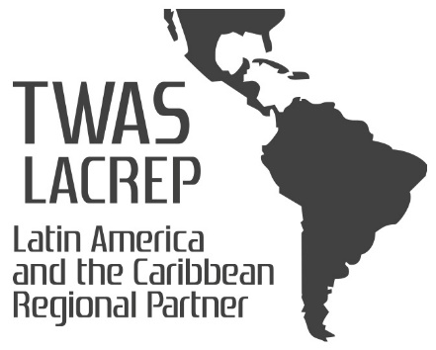
Rio de Janeiro, July 5 th, 2022.

Dear Affiliates and Fellow of TWAS-LACREP,

We invite you to nominate the brightest young scientists in your region to become Affiliated Members of TWAS. Please find enclosed the Nomination Form for Affiliated Membership of TWAS 2022.

Only those Young Scientists who have attained high international standard and have made significant contributions to the advancement of science should be nominated for this prestigious distinction.

Note that it was decided by TWAS to begin to operate a two-track procedure whereby nominations could be received from any suitable individual or organization (e.g. academies of science, centers of excellence), as well as opening up the procedure to simple applications from individual young scientists. Therefore, we would be very gratefull if you could distribute the attached file to all your networks, university, etc.

Requirements:
- be aged 40 or less on January 1st of the year in which they are selected;
- have been living and working in a developing country for at least the preceding three years;
- have an excellent track record of at least 10 international publications in peer-reviewed journals.

The deadline for submission of nominations is August 4st 2022.

'Women are especially encouraged to apply.'

Sincerely,

Virgílio Almeida
Head of TWAS LACREP

